Nguyen Trong Hiep

Mssv :1362018

Class diagram

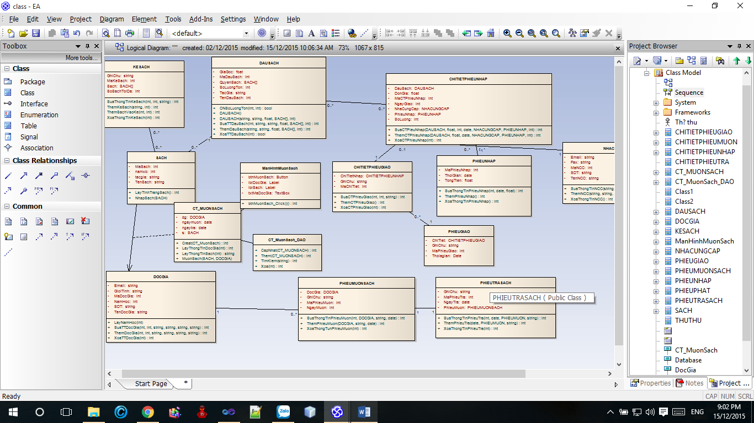

Sequence

